**Environmental Setup**

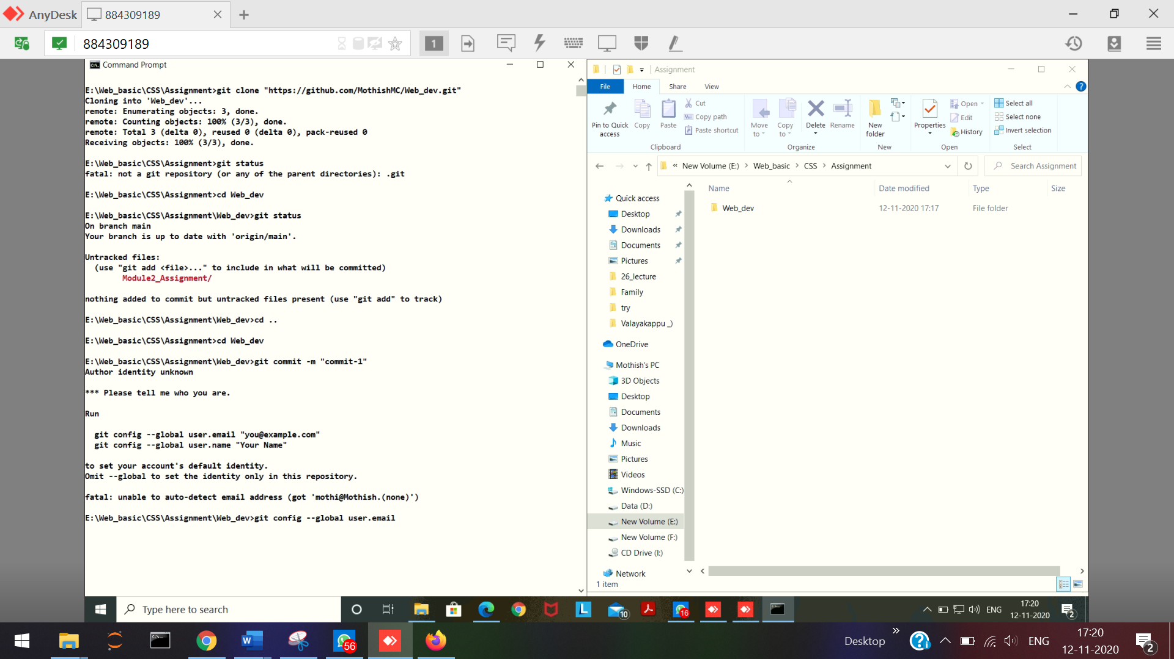

git --version   
node --version   
npm --version  
npm install -g browser-sync 🡪 To install browser sync  
browser-sync --version 🡪

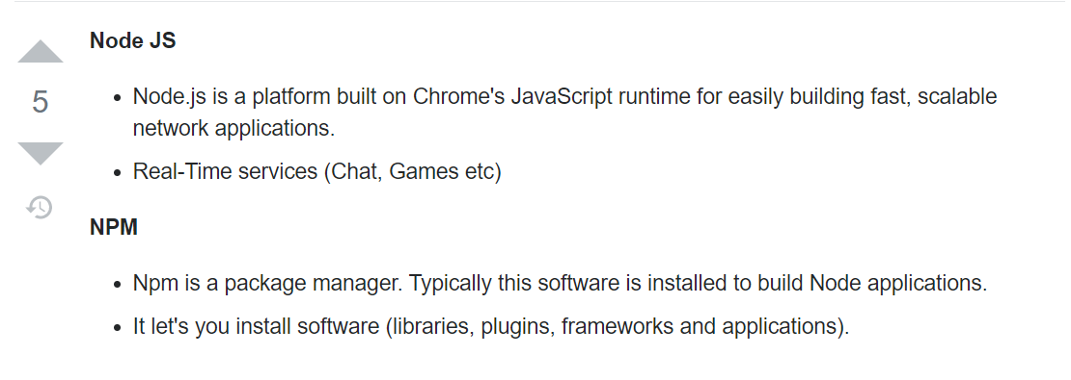

Create a New repository

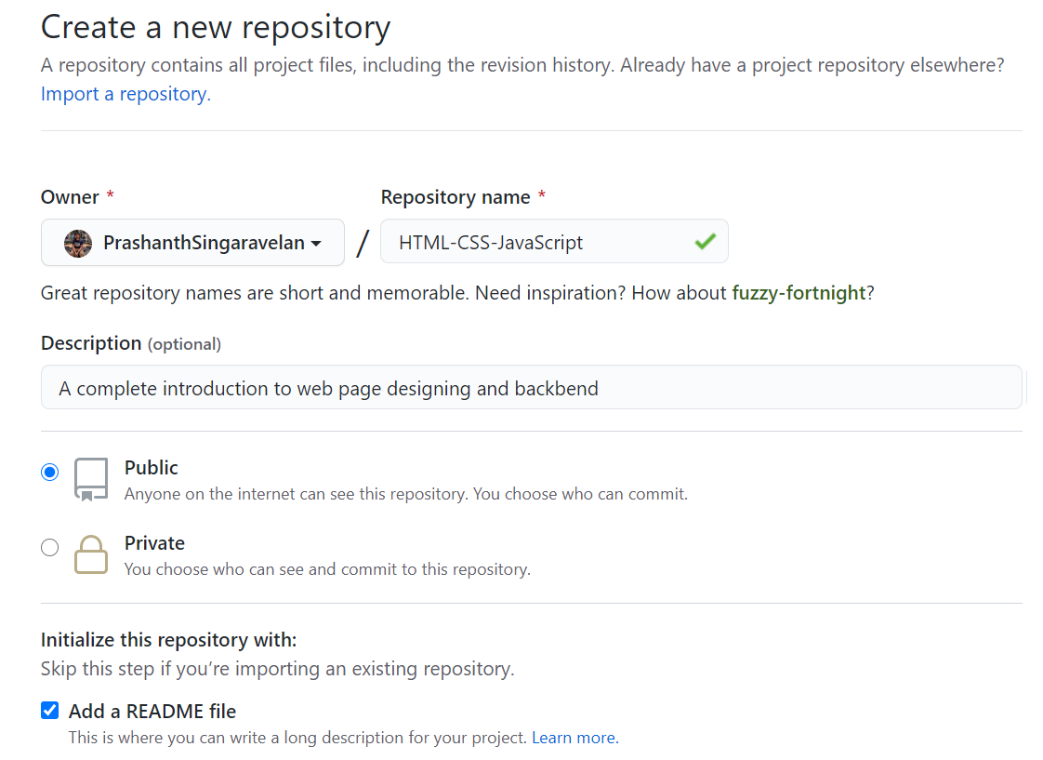  
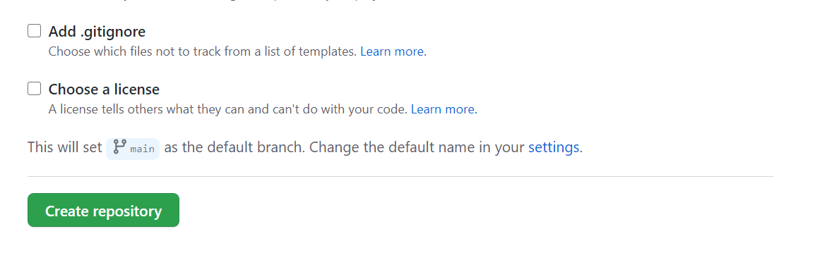

Settings 🡪 github pages   
Select the themes and apply. Go to the Settings 🡪 github pages, and use the link to see the theme applied page

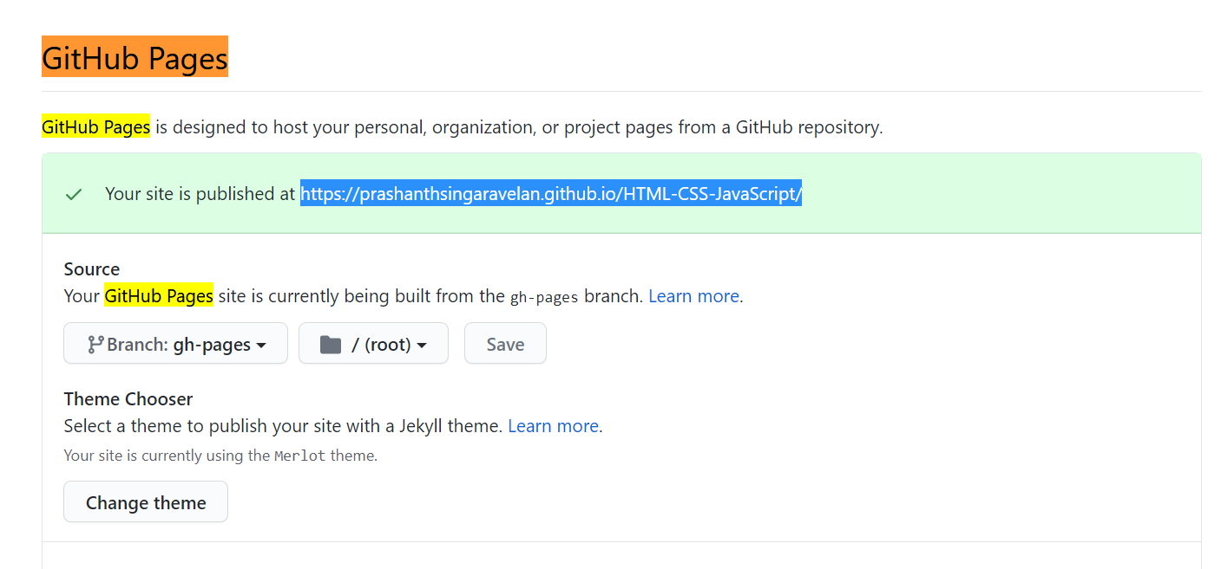

To see the branches in our repository

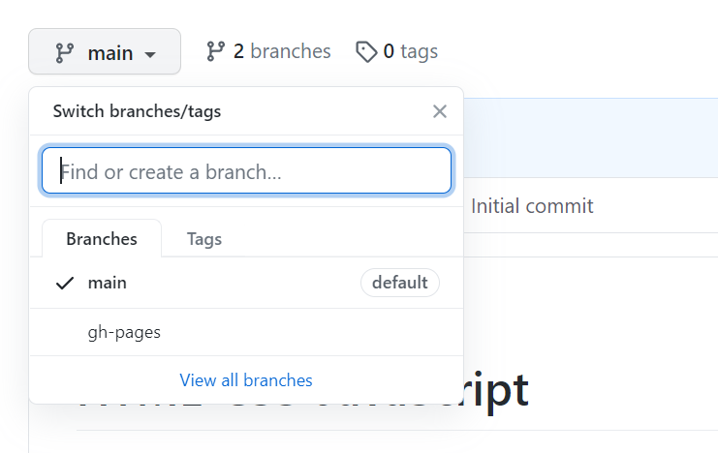

Do everything in the **gh-pages** branch, in this only will show up the special link you created. Other branches won’t show up on the local-host.

Select the gh-pages branch and clone with the local machine.

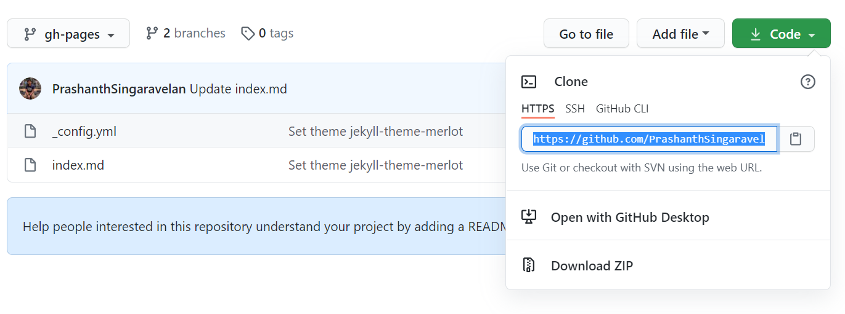

Copy the link and clone

1. ***git clone “repository link”*** 🡪 To get the repository from the net and load into the local machine.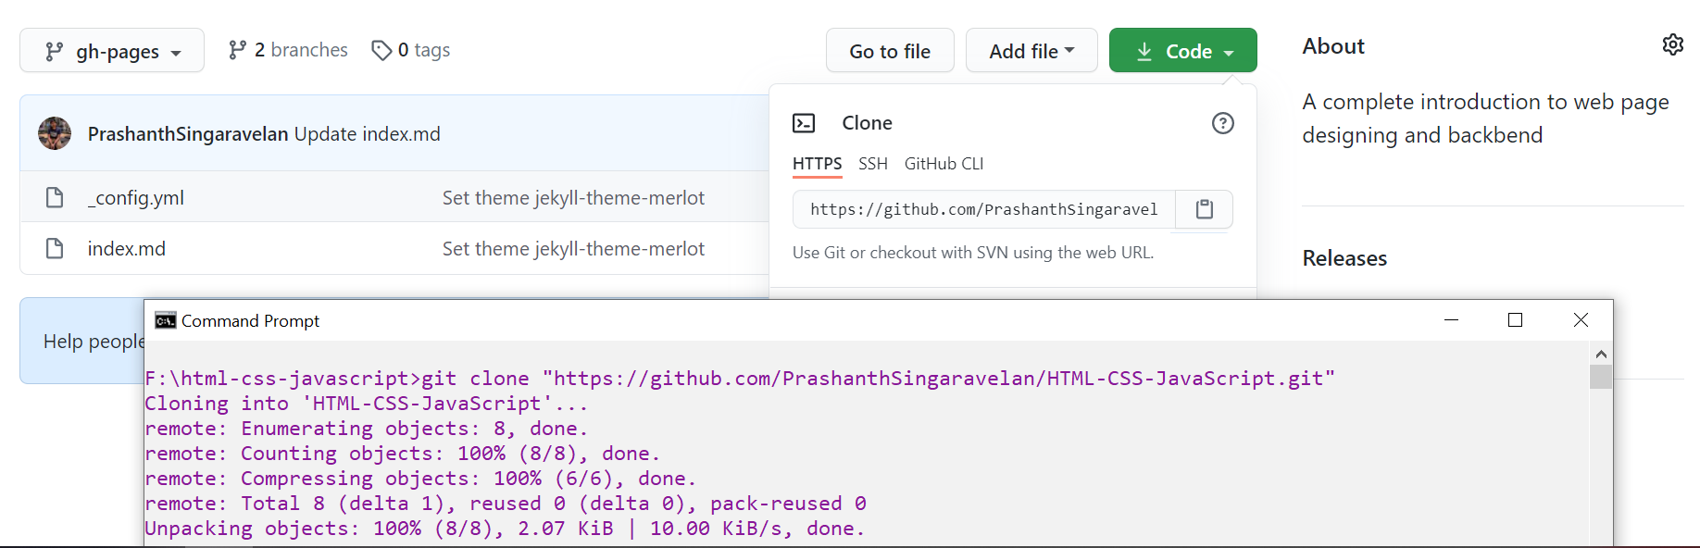



dir 🡪 To show the files in our directory

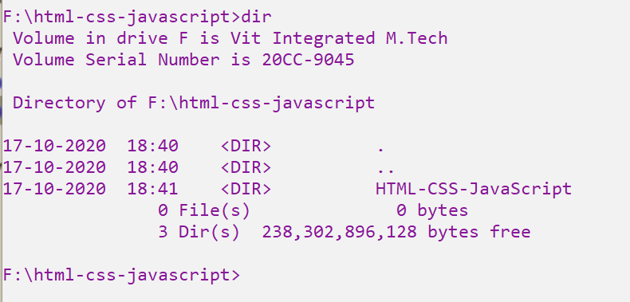



Successfully cloned

After cloning successfully a file will be created with the name of the cloned repository. Go inside the file and see the status.   
2) ***git status*** 🡪 (To know the particular status of the repository). This respository is only having the branch master and nothing else

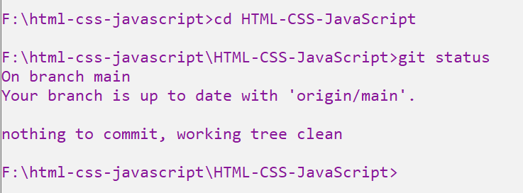



Now we are in **main** branch. Switching to **gh-pages** branch.

3)***git checkout “branch_name”*** 🡪 To switch out a specific branch

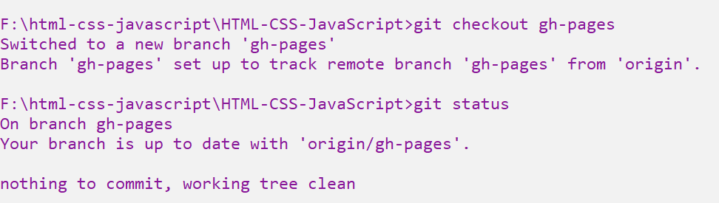

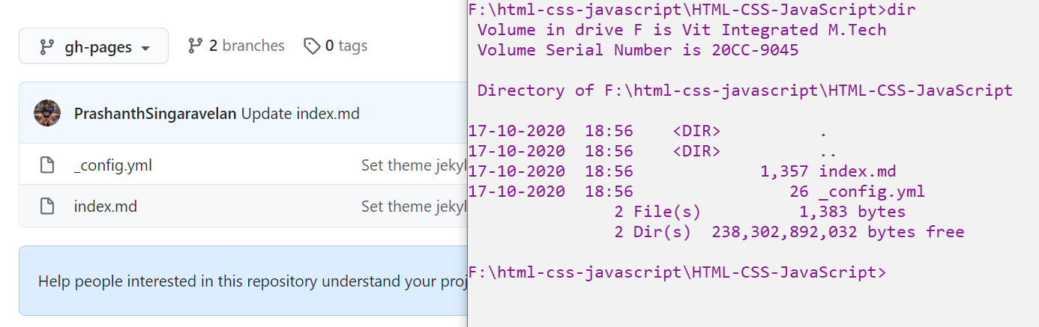

Now the file in our repository is clonned perfectly.

4)***mkdir “file_name”*** Created a new directory 🡪 For our website  
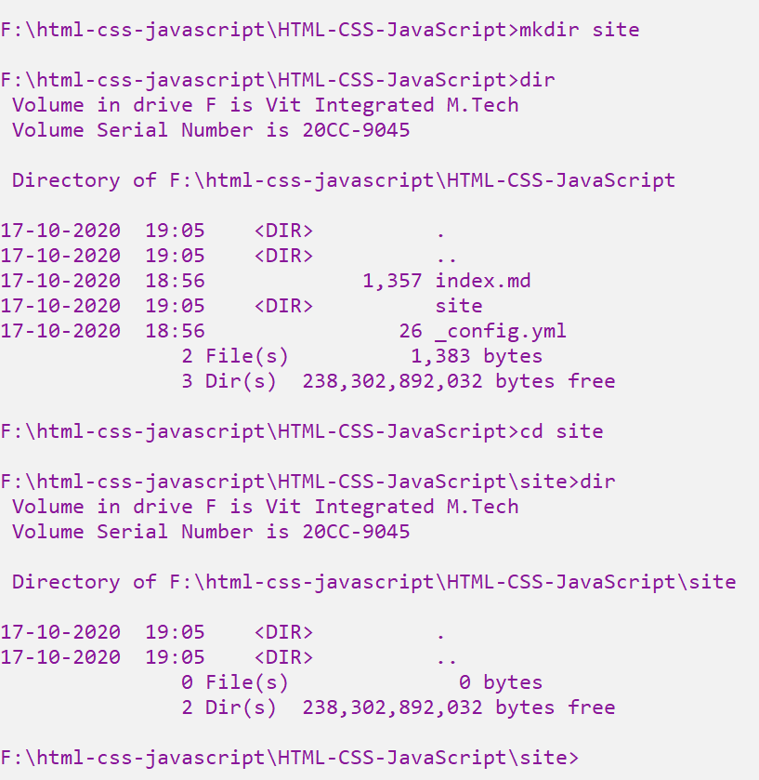



The site file is empty

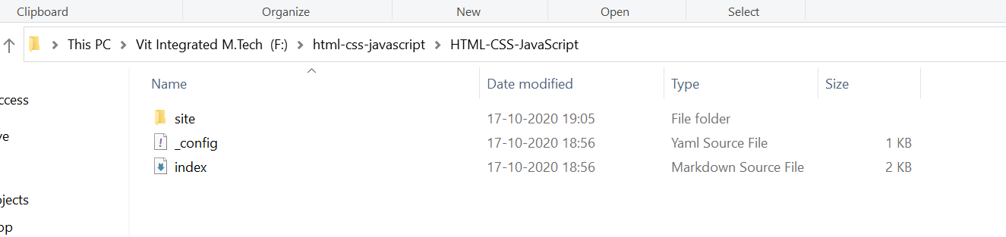

Go inside the site folder and create a **index.html** file

Press html. Click ctrl+space 🡪 to get the basic html tags.

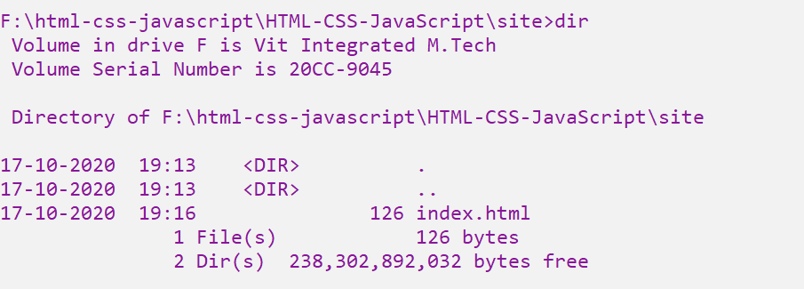



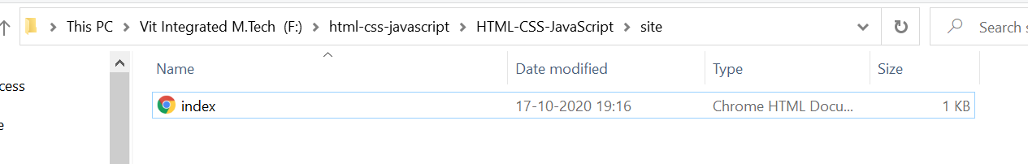



Seeing the status

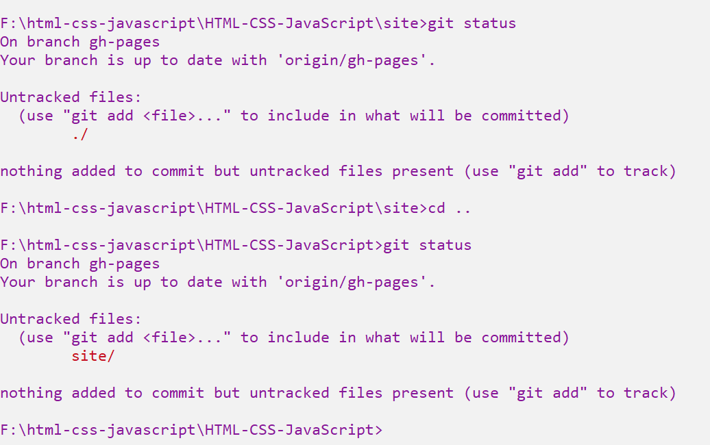  
This clearly indicates that “index.html” file and the “site” folder are not commited.



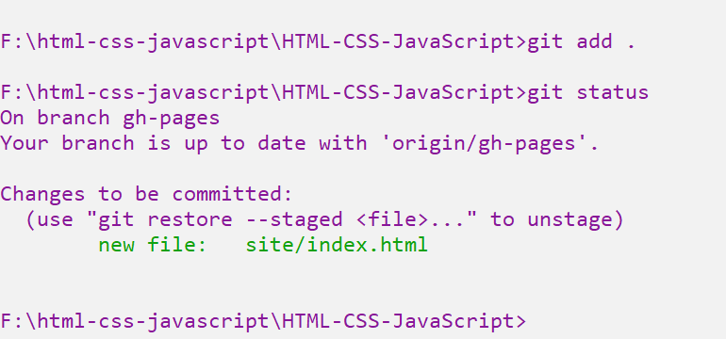



Now the file is successfully marked to be commited. But not actually commited.

5) ***git commit -m “Commit_message”* 🡪** Now the file is succeffully committed in the local repository. Now we want to commit into the global repository.

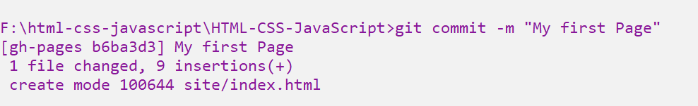

6) ***git push*** 🡪 Pushing the locally commited file into the global github page

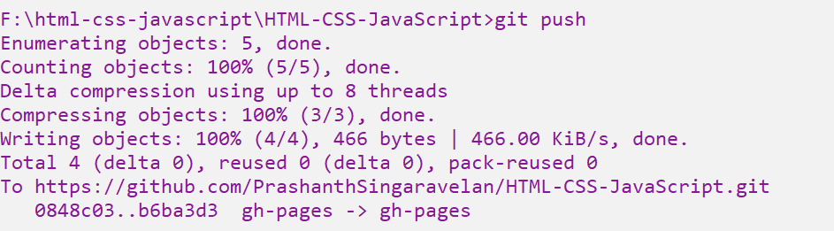



Local 🡪 global

Referesh the git hub page, and the site folder is succefully commited in the global github

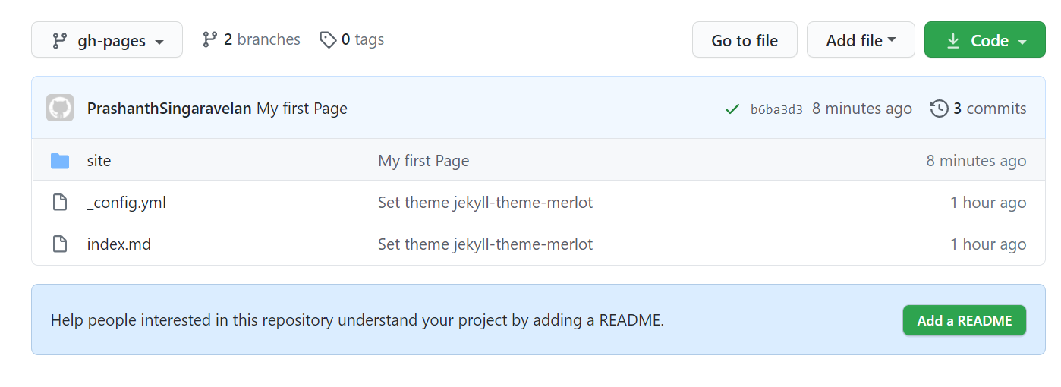  
 Commit message



After making changes in the html code,

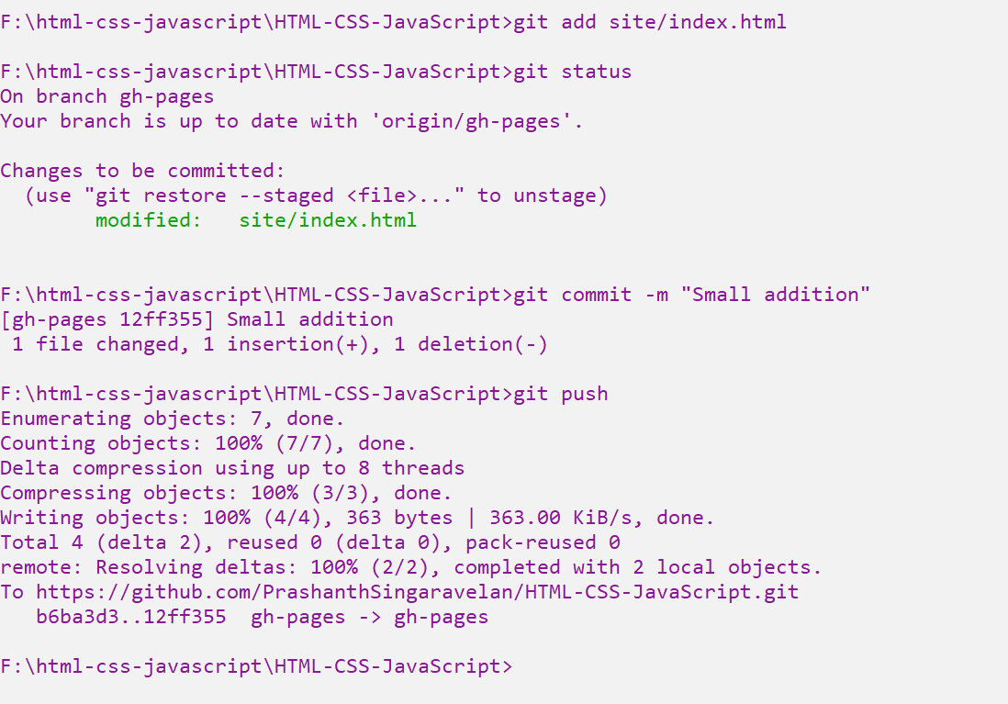

Refresh the web site to see the changes.

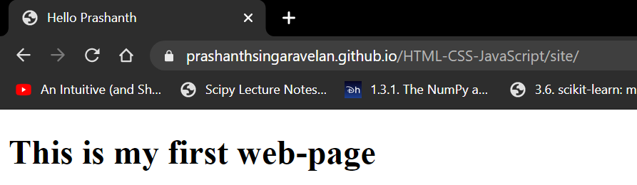



6) ***browser-sync start --server --directory --files "*" 🡪*** To host the web-browser, continuously

If the web-pages are not starting automatically, then include this “C:\Windows\System32” in the system variable.

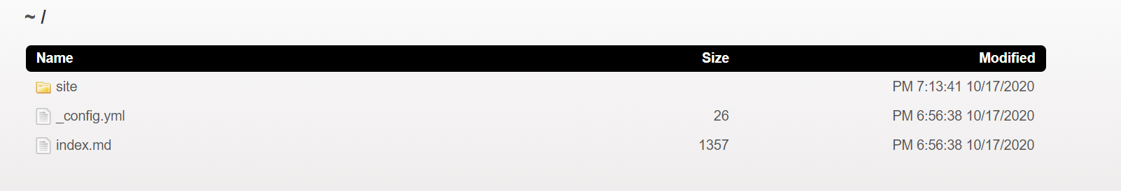

In-order to handle my web-browser and sublime editor simultaneously I am using browser-sync

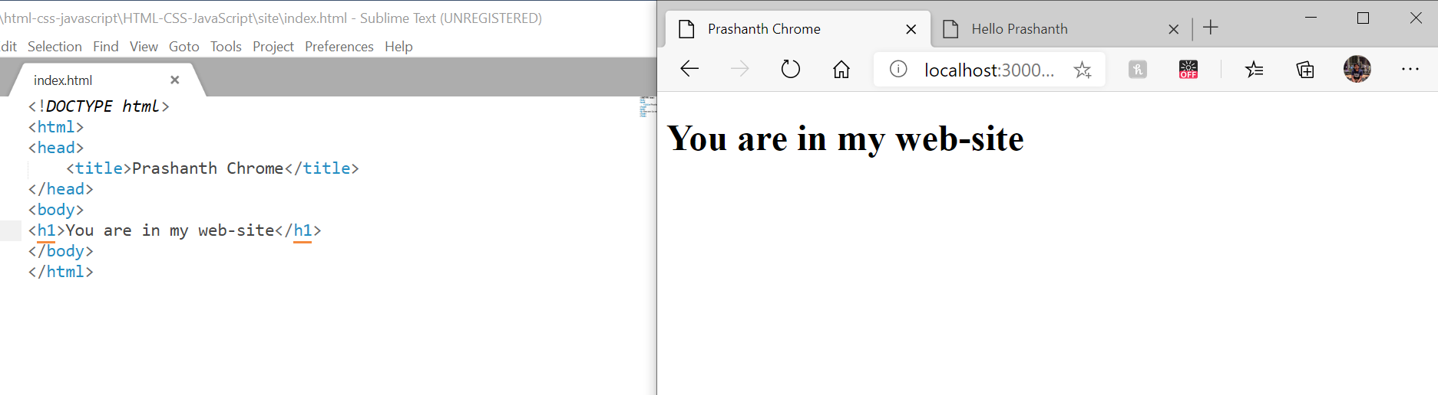

1. In git, each and every thing which you do in your local machine should be committed. If not is will show like this

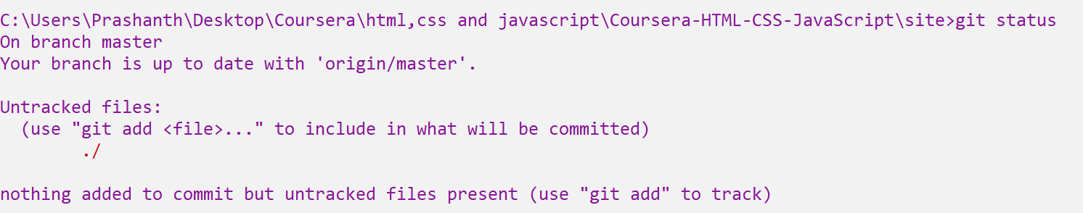

This clearly shows that the code inside the “site” file is not committed.

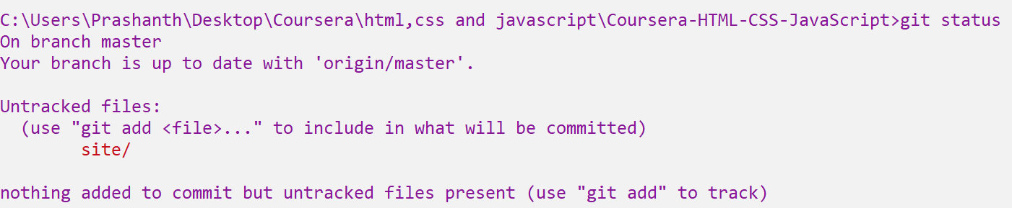

1. ***git add .*** 🡪 Marked to be Committed the code inside the “site” file



After marked to be committed , it shows up as green to ensure that the files are committed successfully.

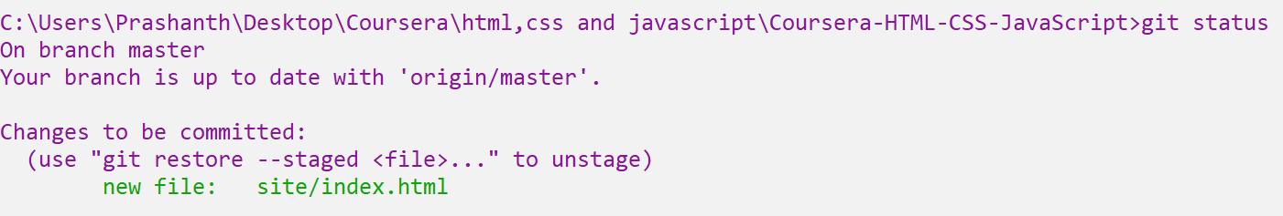

1. ***git commit -m <”Commit message”>*** 🡪 This commits and will save the message while the commit take place in-order for the retrieval purpose.



1. Now the file in the local machine is committed, we want to push this committed file into the remote git repository.

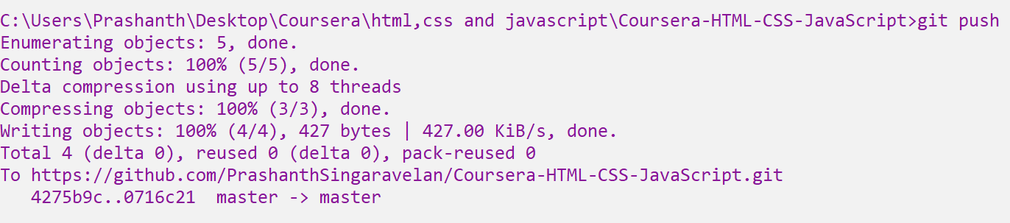  
 from local to the remote



